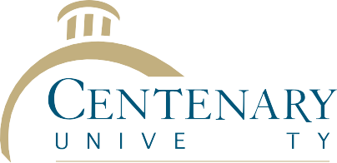

Employee Award Nomination Form

Innovation Award
This award recognizes the outstanding accomplishments of an employee who has generated novel and valuable ideas and used these ideas to develop new or improved processes, methods, systems, programs and services that have improved the University and have made Centenary University a better place to work. The idea(s) should result in cost savings to the University. Nominations must be submitted by filling out the form below and addressing each of the criteria as outlined below. All entries should be delivered directly to the President’s Office by no later than 4:00 pm on August 23, 2017.
Date:____________________
Nominee Name:__________________________________________
Job Title:________________________________________________
Contact info:____________________________________________
Nominated by:__________________________________________
Job Title:_______________________________________________
Contact info:___________________________________________

Award Criteria (please address in detail all 8 categories below):
- Worked to improve any area of the University’s operation.
- Identified creative solutions that have made a significant and positive difference.
- Suggested new ways to improve the quality of services or programming.
- Identified novel approaches for completing work more effectively or efficiently.
- Identified new ideas, solutions or directions.
- Worked to develop new approaches when problem solving; sought ideas or suggestions from others as appropriate.
- Planned effectively for the successful implementation and long-term success of new services, systems or programming.
- Results must be quantifiable.

